Ella Whitney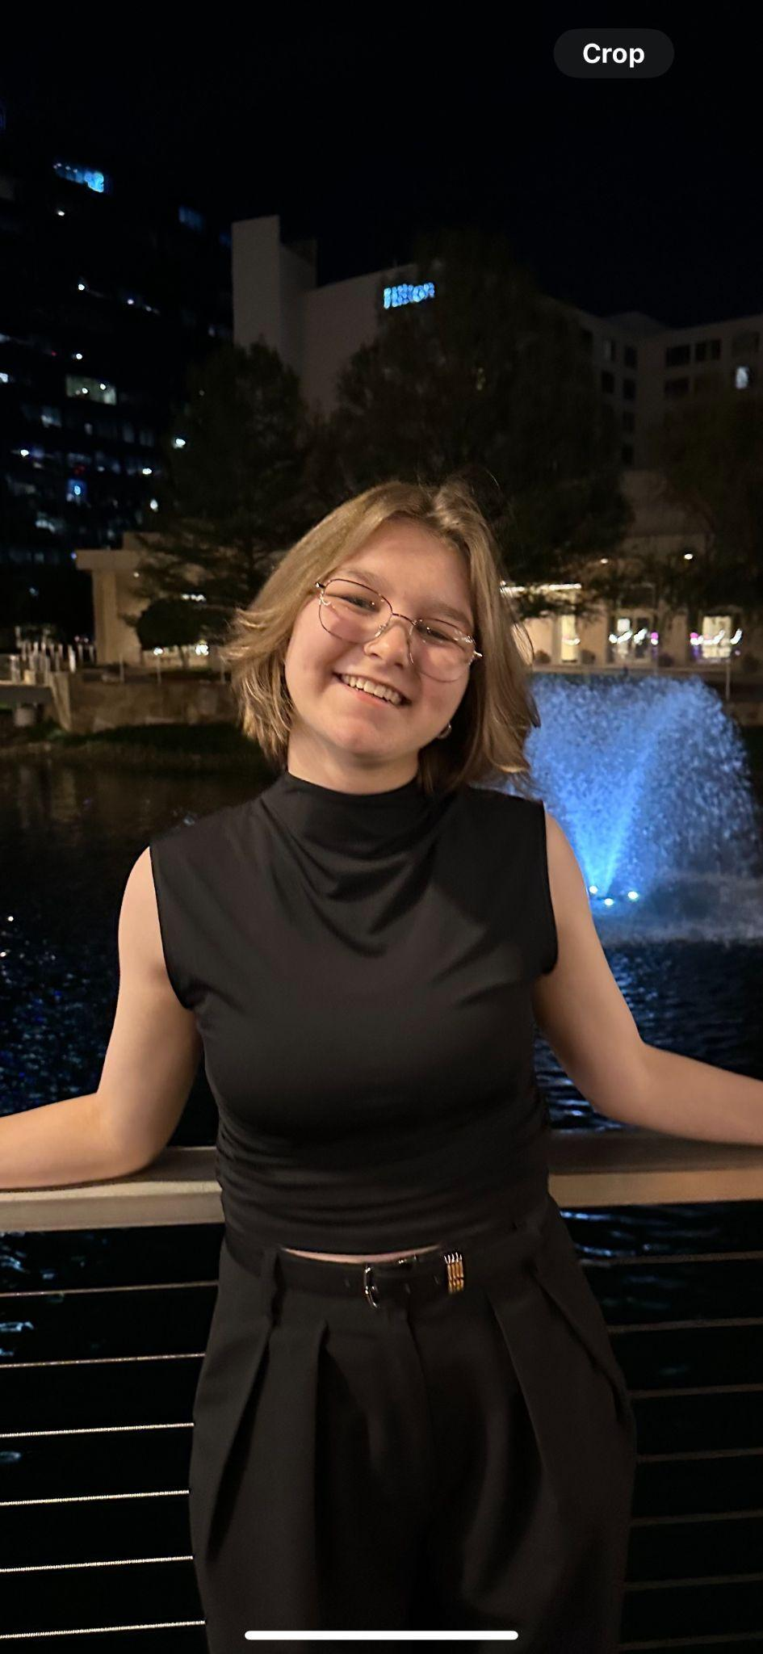

ellawhitneyr@gmail.com

Senior

The University of Texas at Austin

Computer Science/Turing Scholars

This year I worked on designing and creating the map for the port area of the city based on the concept art, including the structures, landscape, and surrounding ocean. I also created the time looping system as well as the primary lighting and the day/night cycle which aligns with the time system design. I also helped with story design, and implementing a level change feature which enables the game progression.